Nutanix Objects

Introduction

*Nutanix Objects™ (Objects) is a software-defined Object Store Service. This service is designed with an Amazon Web Services Simple Storage Service (AWS S3) compatible REST API interface capable of handling petabytes of unstructured and machine-generated data. Objects addresses storage-related use cases for backup, and long-term retention and data storage for your cloud-native applications by using standard S3 APIs. You no longer have to introduce an external, separately managed storage solution.

Project Summary

|  |  |
| --- | --- |
| Website | https://www.nutanix.com/products/objects |
| Organization/Foundation Name | Cloud Native Computing Foundation |
| License | https://www.nutanix.com/legal/terms-of-use |
| Proprietary | nutanix |
|  |  |
| Brief Description |  |

Project Details :

Key Features

### Ensure compliance and data protection

Enable Write-Once Read-Many (WORM) policies on any object to ensure data fidelity and immutability for data retention and compliance. Protect everything with integrated encryption to a level of FIPS 140-2 compliance.

**Support any workload from a single platform**

Get S3-compatible storage for big data, cloud-native and deep archive workloads. It’s a single, flexible platform that stores file, block, VM, and many other types of workloads.

**Enhance data visibility with tagging and versioning**

Quickly identify objects by tagging them. Tag objects based on projects, compliance and more. Create copies of objects and protect your data from accidentally overwriting or deleting it.

Architecture

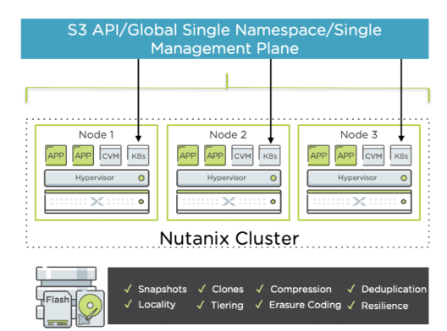

Current Usage

* Department of Work and Pension
* The Home Depot
* Total S.A.
* Mercedes-Benz
* Pay 360
* Tsingtao Brewery

Other Information